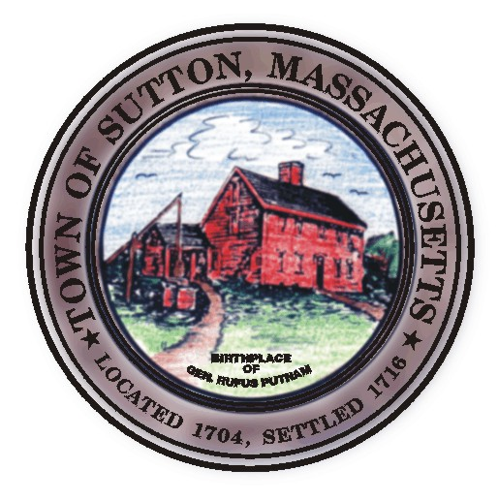

TOWN OF SUTTON ZONING BOARD OF APPEALS
4 UXBRIDGE ROAD · SUTTON, MA 01590 · (508) 865-8723 · FAX (508) 865-8721

ZONING BOARD OF APPEALS
MINUTES
June 7, 2011

Approved by:___________________
Date:__________________________

Board Members Present: Arthur Keown ; Russ Sylvia; Rick Deschenes, Clerk; Jeffrey Fenuccio;
Gerald Page
Secretary: Lynn Dahlin

6:00pm
According to the requirements governed by MGL ch.39 §23D, A. Keown entered into the record affidavits for both Jeffery Fenuccio and himself allowing them to participate in the evenings proceedings.

32 Horne Drive- Decision
John and Cindy Charest
R. Sylvia motioned and J. Fenuccio seconded to grant the applicant’s request for both front and rear lot line setback variances, a lot coverage variance, as well as a favorable finding from MGL.ch 40A §6.
Discussion: None
Vote: 5-0 in favor.

188 Burbank Road- Special Permit for Home Business
Robert Fisher
R. Sylvia motioned and G. Page seconded to grant the Special permit as requested to operate a home business which would allow the parking of (1) commercial vehicle belonging to the resident business person.
Discussion: None
Vote: 5-0 in favor

6:05pm
Meeting Adjourned

Respectfully submitted,

Lynn Dahlin
Secretary

